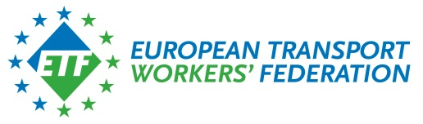

EP(13)43/FISH(13)3538 final Brussels, 10 May 2013

Mr. László ANDOR
Commissioner for Employment, Social Affairs and Inclusion

Mrs. Maria DAMANAKI
Commissioner for Maritime
Affairs and Fisheries

European Commission
1049 Brussels

Re: Implementation of the 8 May 2013 Agreement between the EU social partners in the sea-fisheries sector concerning the implementation of the “Work in Fishing" Convention, 2007 of the ILO

Dear Commissioners,

Since 2010, the EU social partners of the sea-fisheries sector have initiated a negotiation process with a view to conclude an Agreement concerning the implementation of the ILO Convention n°188 on "Work in Fishing".

The negotiation was a follow-up to the invitation expressed by the Commission on the occasion of its "Article 138" (now Article 154 TFEU) consultation of 10.10.2007 concerning the regulatory social framework for more and better seafaring jobs in the EU. The Commission has invited the EU social partners to "examine the possibilities of a joint initiative" in order to promote the implementation of the ILO Convention, at EU level, along the same procedure that was adopted for the implementation of the "Maritime Labour Convention, 2006" of the ILO (Council Directive 2009/13/EC of 6 February 2009).

The negotiation process has been, therefore, developed with the intention to request the EU legislative implementation of such an Agreement, in accordance with Article 155 §2 TFEU. This process made it possible to conclude an Agreement which was formally signed during the European Maritime Day Conference in Gothenburg, on 21 May 2012.

From that date onwards, our three organisations have been working closely to revise the text of this Agreement in cooperation with your services, in order to make it fully compatible with the existing “acquis communautaire” in the sea-fisheries sector and the relevant social dialogue provisions of the Treaty and, thus, make its legislative implementation possible at EU level.

We are now pleased to enclose the revised text of the Agreement which was adopted on 8 May 2013. This text is intended to accommodate the expectations expressed by the services of the Commission and to remove the legal obstacles to its EU legislative implementation.

This revised Agreement confirms the EU’s social partners’ commitment to improve the working conditions of fishermen, both in Europe and globally. The adoption of this revised Agreement implies that the Agreement of 21 May 2012 is now null and void.

In line with Article 155§2 TFEU, the EU social partners in the sea-fisheries sector, represented by Europêche, Cogeca and ETF, formally request the Commission to present to the Council a proposal for a Decision which will make the implementation of this revised Agreement legally binding at EU level.

The EU social partners consider that such a legislative process is the only appropriate one for the implementation of the revised Agreement.

We remain at your disposal for any further clarification you might wish to obtain from us regarding our Agreement.

Yours faithfully,

Mr. Eduardo Chagas Mr. Javier Garat Mr. Giampaolo Buonfiglio
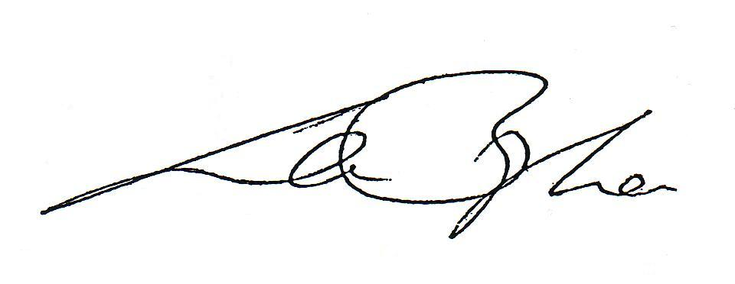
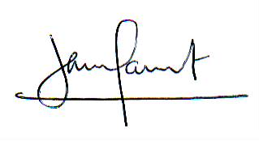
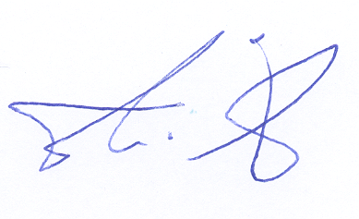

General Secretary of ETF President of Europêche Chairman of the COPA-
COGECA FISH WG

Copy: Messrs. Richelle, Silva, Tricart, Ziegler (DG EMPL)
Mrs. Evans, Montesi, Correia, Mr. Gallizioli (DG MARE)

